SCUBA-2 Block Specification
LVDS Transmitter

February 15, 2005
Table of Contents

1. Block Overview 3
1.1 Block Location and Block Interface Within System 3
1.2 Block Functionality / Features 3
1.3 Block Dataflow 3
2. Block Interfaces 4
2.1 Interface Signal Description 4
2.2 Interface Protocol and Timing 5
3. High-Level Description 8
3.1 State Machine Description 8
3.2 Special Optimizations 8
4. Files of the Block 9
4.1 Source Code 9
4.1.1 lvds_tx.vhd 9
4.2 Header Code 9
5. Naming Conventions Used 10

Block Overview

Block Location and Block Interface Within System
The LVDS transmitter is used by the following modules:
- cmd_queue
- dispatch

Block Functionality / Features
- Accepts a 32-bit word and transmits it over an LVDS serial link (four transmit cycles of 8-bits each)
- Indicates transmission status using a busy signal.

Block Dataflow

lvds_tx

busy_o

rdy_i

Transmit Controller
byte_count

dat_i

tx_busy
tx_rdy

clk_i

tx_data
buffer_out

async_tx
lvds_o

rst_i

comm_clk_i

Clock Divider
Data Buffer
Byte Counter

Block Interfaces

Interface Signal Description
- Interface Signals
Signal | Description | Direction
Global Signals
clk_i | Global clock signal | in
comm_clk_i | Global communications clock signal | in
rst_i | Global asynchronous active-high reset | in
Data and Status Signals
dat_i | Parallel input data (32-bit word) to be sent. | in
rdy_i | Ready signal. Indicates that the data on dat_i is valid. | in
busy_o | Busy signal. Indicates that the module is transmitting. | out
LVDS Output
lvds_o | Serial output data to LVDS drivers. The output stream is framed according to RS-232 protocol. | out

Interface Protocol and Timing

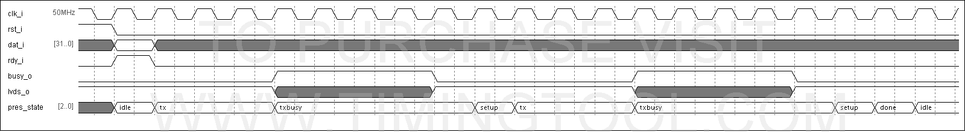

High-Level Description

State Machine Description
Transmit controller state diagram:
tx_busy = ‘1’
tx_busy = ‘0’

idle

tx
tx busy

rdy_i = ‘1’
tx_busy = ‘1’
rdy_i = ‘0’

tx_busy = ‘0’
byte_count < 3

setup

done

byte_count = 3

Transmit controller state outputs:

Present State | Output Signal
Present State | tx_rdy | buffer_ena | byte_count_ena | byte_count_clr | busy_o | tx_data
IDLE | 0 | 1 | 1 | 1 | 0 | “00000000”
TX | 1 | 0 | 0 | 0 | 1 | byte from buffer
TXBUSY | 0 | 0 | 0 | 0 | 1 | “00000000”
SETUP | 0 | 0 | 1 | 0 | 1 | “00000000”
DONE | 0 | 0 | 0 | 0 | 1 | “00000000”

Files of the Block

Source Code

lvds_tx.vhd
This file contains the LVDS transmitter implementation. It is compiled into the “work” library.

Header Code
Not applicable for this block

Naming Conventions Used

